Getting Started on Windows and Mac

Overview
Zoom unifies cloud video conferencing, simple online meetings, and group messaging into one easy-to-use platform. Our solution offers the best video, audio, and wireless screen-sharing experience across multiple platforms. Follow this article to learn about the basic features of the Zoom client on Windows and Mac.

Prerequisites
- Zoom desktop client (Windows or Mac)
This article covers:
- Sign in and Join
- Home
- Chat
- Phone
- Meetings
- In-Meeting Controls
- More Resources

Sign in and Join
After launching Zoom, click Join a Meeting to join a meeting without signing in. If you want to log in and start or schedule your own meeting, click Sign In.
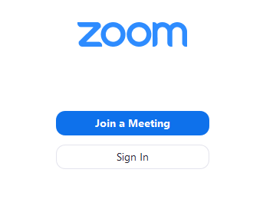
To sign in, use your Zoom, Google, or Facebook account. You can also log in using SSO. If you don't have an account, click Sign Up Free. If you have a Zoom account but cannot remember your password, click Forgot.
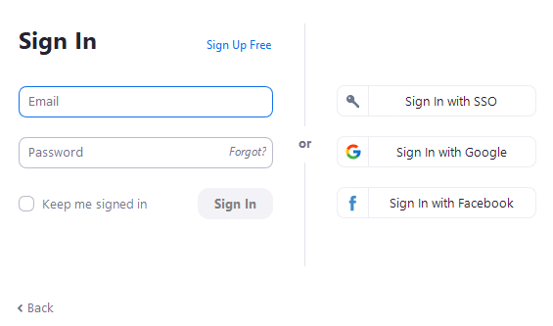

Home
After signing in, you will see the Home tab, where you can click these options:
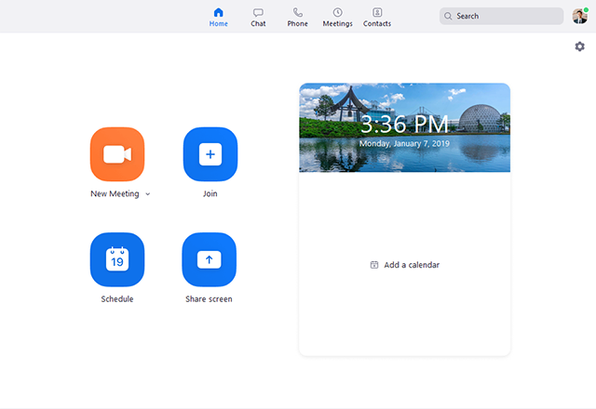
- New Meeting: Start an instant meeting. Click the downwards arrow to enable video or use your personal meeting ID (PMI) for instant meetings.
- Join: Join a meeting that is in progress.
- Schedule: Set up a future meeting.
- Share Screen: Share your screen in a Zoom Room by entering in the sharing key or meeting ID.
- Date and time with background image: To change the background image, hover over the picture and click the camera icon.
- Upcoming meeting: Displays the next meeting for the current day. Add a third-party calendar service if you want to sync upcoming meetings.
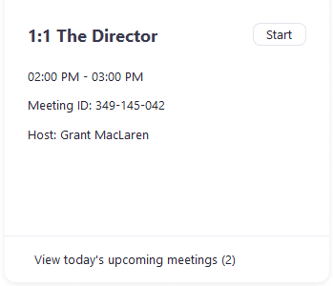
- Click your profile picture for these options:
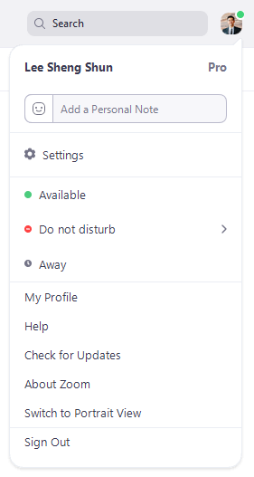
  - Add a personal note.
  - Settings: Access settings you can change in the client.
  - Change your status to Available, Away, or Do Not Disturb.
  - My Profile: Open the Zoom web portal to edit your profile.
  - Help: Open the Zoom Help Center.
  - Check for Updates: Check if Zoom is up to date.
  - About Zoom: View the current version.
  - Switch to Portrait View: Switch the Zoom window to portrait view if you prefer a narrower window.
  - Sign out
  - Upgrade to Pro (if you are on a free account)

Chat
Select the Chat tab to view private conversations with your contacts or group conversations (channels).
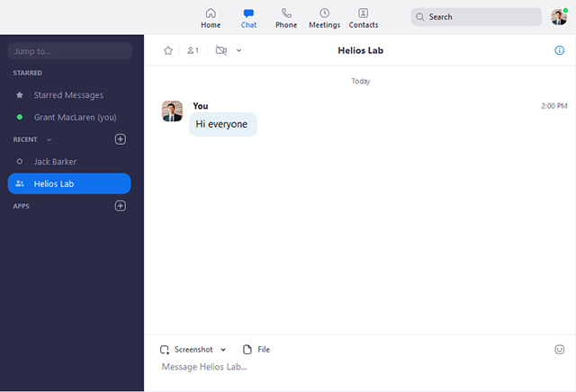
You can access these features in the left-side panel:
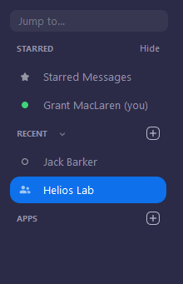
- Jump to search box: Search for a contact or channel.
- Starred Messages: View messages you have starred.
- Click your name to use your personal chat space.
- Add icon (next to Recent): Start a new chat with one of your contacts, create a channel for group chats, or join an existing channel.
- Under Recent, click a contact to view chat history and continue to chat with them. Contacts have a status icon before their name.
- Under Recent, click a channel (indicated by the group icon before the name) to view the channel's chat history and send messages to channel members.
After selecting a contact or channel in the left-side panel, you can use these features in the chat window:
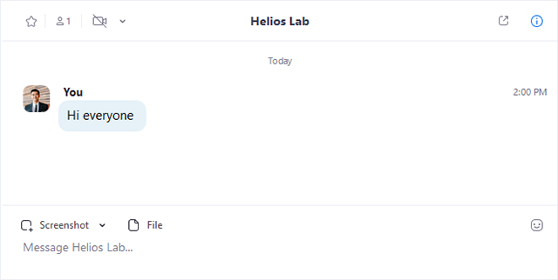
- Star icon : Add the contact or channel to your starred list, giving you quick access to those contacts or channels.
- Video icon : Start a meeting with the contact. If a channel is selected, this will start a meeting with all members of the channel.
- New window icon (hover your pointer over the contact or channel name to display this icon) : Opens the selected chat in a new window.
- Info icon : View additional options for the contact or channel. Also gives you quick access to files, images, and starred messages in the selected chat.
- Message box: Compose and send messages to your contact or channel. You can also send screenshots, files, code snippets, and animated GIFs.

Phone
Select the Phone tab to make phone calls, view call history, and play voicemail messages using Zoom Phone.
Note: Zoom Phone licence is required.
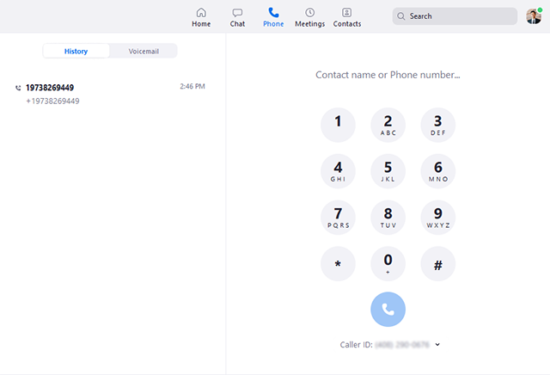

- History tab: View and delete call history and recordings.
- Voicemail tab: Play and manage voicemail messages.
- Dial pad: Make outbound calls by manually entering a phone number or searching through your contacts.
Learn more about using Zoom Phone features.

Meetings
Select the Meetings tab and click Upcoming to view, start, edit, and delete scheduled meetings.
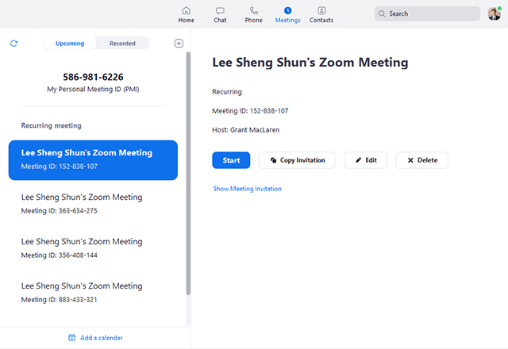
You can click the following options after selecting a scheduled meeting in the left-side panel:
- Add icon : Schedule a new meeting.
- Refresh icon : Refresh the meeting list if you don't see your scheduled meeting.
- Start: Start the scheduled meeting that you have selected in your upcoming meetings.
- Copy Invitation: Copy the scheduled meeting's invitation text, allowing you to manually paste into an email, instant messenger etc. Click Show Meeting Invitation if you want to view the invitation you're copying.
- Edit: Edit the meeting options for your scheduled meeting.
- Delete: Permanently delete your scheduled meeting.

Contacts
Select the Contacts tab to view and manage your contacts.
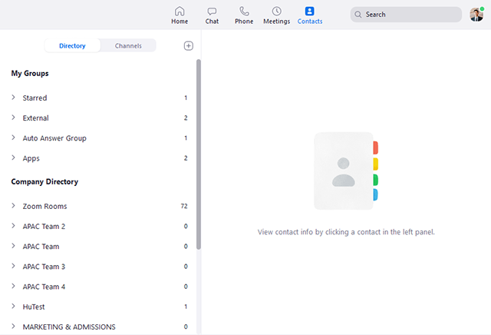
- Directory tab: View a directory of all your contacts, including starred, external, and auto answer contacts. If your organization has Zoom Rooms, you will also see a list of Zoom Rooms.
- Channels tab: View a directory of your channels (used for group messaging). Starred channels appear at the top of the list.
- Add icon : Show options for contacts and channels. You can add a contact, create a contact group, create a channel, or join a channel.

In-Meeting Controls
Once you have started or joined a meeting, you can access the meeting controls located at the bottom of the meeting window (move your mouse in the Zoom window to display meeting controls).
Learn more about meeting controls for hosts, co-hosts, and attendees. You can also join a test meeting to familiarize yourself with meeting controls before joining a scheduled meeting.
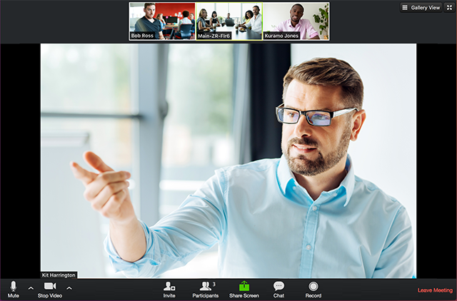

More Resources
- Watch the Getting Started Videos
- Join our Weekly Zoom Meetings and Webinar training
- Join a test meeting

